NeuroXAI: A Dual-Stream Explainable AI Framework Integrating MRI and Clinical Biomarkers for Cognitive Impairment Screening
1st Author 1  [Department / Program name]  [Institution name]  [City, Country]  [email address] | 2nd Author 2  [Department / Program name]  [Institution name]  [City, Country]  [email address] | 3rd Author 3  [Department / Program name]  [Institution name]  [City, Country]  [email address]

Abstract—By the time Alzheimer’s disease (AD) is usually diagnosed, a great deal of irreversible damage has already taken place in the brain. This has pushed researchers toward building screening tools that can flag cognitive decline earlier, ideally by combining brain scans with the clinical information that doctors already collect. In this work we describe NeuroXAI, a two-branch deep learning system that looks at a brain MRI scan through a ResNet-18 convolutional network while separately processing six everyday clinical measurements — age, sex, years of education, the MMSE score, the CDR Sum-of-Boxes score, and the Functional Activities Questionnaire (FAQ) score — through a small neural network. The two resulting feature sets are joined together and passed to a final classifier. Rather than relying on synthetic or simulated data, we built and tested the system on real, subject-matched records pulled from the Alzheimer’s Disease Neuroimaging Initiative (ADNI): 403 individuals for whom we had both a usable baseline/screening MRI scan and a complete clinical record, covering the Cognitively Normal (CN), Mild Cognitive Impairment (MCI), and Alzheimer’s Disease (AD) groups. Because the AD and MCI groups were relatively small, we chose to simplify the task into two categories — Normal versus Impaired (MCI or AD combined) — which is a common and accepted workaround when working with limited clinical datasets. On a held-out test group (20% of the 402 subjects remaining after basic data cleaning), the model reached 93.83% accuracy and a weighted F1-score of 0.939. To make the model’s reasoning visible rather than hidden, we added Grad-CAM for highlighting relevant brain regions on the scan, along with a simple perturbation-based method, similar in spirit to SHAP, that shows how much each clinical score pushed the prediction one way or the other. This paper walks through the full pipeline — from raw ADNI files to a working web dashboard — and is upfront about the trade-offs involved in the binary simplification and the modest dataset size, with suggestions for how a larger cohort could support full three-class staging in the future.
Index Terms—Alzheimer’s disease, explainable artificial intelligence, multimodal fusion, convolutional neural network, Grad-CAM, SHAP, ADNI, magnetic resonance imaging.
I. Introduction
Alzheimer’s disease and other forms of dementia rarely appear suddenly — they tend to develop gradually, often passing through a stage known as Mild Cognitive Impairment (MCI) before symptoms become obvious. Catching this decline early matters a great deal in practice, since it gives patients and families more time to plan, opens the door to treatments that may slow progression, and allows people to be considered for clinical trials. Most memory clinics already gather two kinds of information that could help with this: structural brain scans (MRI) and short cognitive tests such as the Mini-Mental State Examination (MMSE) or the Clinical Dementia Rating (CDR). In practice, though, these two sources are usually reviewed separately rather than combined.
Deep learning is a natural fit for combining imaging and clinical data automatically, but one obstacle to using it in a clinical setting is that neural networks tend to behave like a “black box” — they produce an answer without showing their work. Explainable AI (XAI) methods try to close this gap. Grad-CAM [2], for example, highlights which parts of an image a convolutional network paid attention to, while attribution techniques inspired by SHAP [3] estimate how much each individual input feature pushed a prediction in a given direction. Giving clinicians this kind of visibility is a reasonable first step toward building trust in an automated system.
The contributions of this paper can be summarized as follows. First, we build a two-branch fusion model that pairs a ResNet-18 image encoder with a small neural network for clinical features. Second, we put together a complete, repeatable pipeline that takes raw ADNI exports — both the tabular records and the DICOM imaging files — and turns them into a single, subject-matched dataset ready for training. Third, all results reported here come from real ADNI data (402 subjects), not synthetic placeholders, and we include the full training behavior rather than just a final number. Fourth, we attach both Grad-CAM and a perturbation-based clinical attribution tool so that each prediction comes with a visual and a tabular explanation. Finally, we are transparent about a design choice we had to make: given how few AD and MCI subjects were available, we collapsed the original three-way CN/MCI/AD classification into a simpler Normal-versus-Impaired task, and we explain clearly why this was necessary rather than quietly presenting an inflated accuracy figure.
II. Related Work
Convolutional neural networks, and ResNet architectures [1] in particular, have become a standard choice for classifying Alzheimer’s disease from structural MRI, whether applied to individual 2D slices or full 3D volumes. A recurring finding across this body of work is that combining imaging with clinical or cognitive data tends to outperform models that rely on imaging alone — scores such as MMSE, CDR, and FAQ [6], [7] appear to carry diagnostic information that complements, rather than duplicates, what can be learned from a scan. More recent multimodal work has pushed this idea further by fusing MRI with additional modalities such as PET and CT, or by combining cross-sectional and longitudinal imaging, generally reporting accuracy gains over single-modality baselines [9]. On the explainability side, Grad-CAM [2] has become a popular tool for producing rough visual maps of which image regions drove a convolutional network’s decision, while SHAP-style attribution methods [3] offer a way to quantify how much each individual tabular feature contributed to a prediction; a recent survey of explainable AI in Alzheimer’s neuroimaging similarly identifies Grad-CAM, SHAP, LIME, and layer-wise relevance propagation as the dominant interpretability techniques in this space, while also noting persistent challenges around dataset limitations and standardization [10]. Broader reviews of deep learning for AD detection [11] likewise emphasize that multimodal fusion and explainability are two of the most active directions in the field, and that some ADNI-based studies have combined cognitive, demographic, and even language-model-based approaches to push classification accuracy higher still [12]. Much of this research, including the present study, relies on the ADNI project [4], which remains one of the largest and most widely used public resources combining longitudinal MRI, PET imaging, cognitive testing, and biomarker data from a multi-site patient cohort.
III. Materials and Methods
A. Dataset
All data used in this study were downloaded from the Alzheimer’s Disease Neuroimaging Initiative (ADNI) database (adni.loni.usc.edu) under an approved data use agreement. Demographic and cognitive variables for each subject came from ADNI’s Subject-Level (ADSL) table, while T1-weighted MPRAGE MRI scans were pulled separately, restricting the search to the Screening and Baseline visits and to scans explicitly tagged as MPRAGE sequences under the MRI modality. We then matched subject identifiers between the imaging records and the ADSL table, keeping only subjects who had both a usable scan and a complete diagnosis (the DX field, recorded as CN, MCI, or Dementia/AD). This left us with 403 subjects, distributed across the three diagnostic groups as shown in Fig. 1(a).

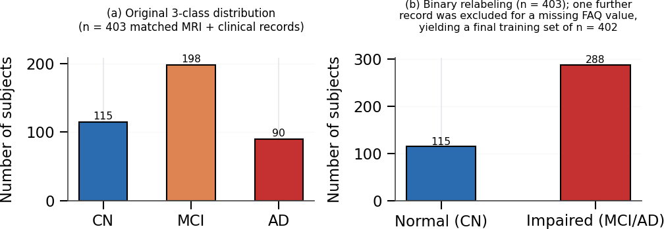
Fig. 1. Diagnostic class distribution of the matched ADNI cohort. (a) Original three-class distribution (CN/MCI/AD). (b) Binary relabeling used for model training, with one additional subject excluded during quality filtering for a missing FAQ value.

With only 90 subjects in the AD group and 403 subjects overall, trying to train a reliable three-class image-plus-clinical model turned out not to work well in practice — early experiments showed the validation performance swinging unpredictably from one epoch to the next, a typical sign of the model overfitting to the smaller classes rather than genuinely learning from them. To work around this, we merged the task into two groups instead of three: Normal (the original CN label, now 0) and Impaired (MCI and AD combined into label 1). This kind of simplification is fairly common when a clinical dataset is too small to support a finer-grained classifier. Fig. 1(b) shows what this regrouping looks like (115 Normal, 288 Impaired, out of 403 subjects). One additional subject was dropped before training because their FAQ score was missing, leaving a final working set of 402 subjects.

B. Clinical Feature Selection
We kept six clinical and cognitive measurements as inputs to the model: age, sex, years of education, the MMSE score [6], the CDR Sum-of-Boxes score [7], and the total FAQ score [8]. Two measurements from the original project plan — normalized whole-brain volume (nWBV) and estimated total intracranial volume (eTIV), both borrowed from the OASIS dataset’s conventions — were left out for the ADNI cohort. The reason is practical: ADNI’s brain-volume table (UCSFFSX51) breaks the brain down into more than 150 separate anatomical regions rather than providing one combined whole-brain figure, and we felt that trying to combine these ourselves risked introducing quiet calculation errors we might not catch.

C. Image Preprocessing
For each subject, we picked out whichever DICOM series had the most slices, treating it as the main MPRAGE scan for that person. From that series we took the middle slice — a representative axial cross-section of the brain — converted it to grayscale, duplicated it across three color channels, resized it to 224×224 pixels, and normalized the pixel values using the standard ImageNet statistics that the pretrained ResNet-18 backbone expects.
D. Model Architecture
Fig. 2 shows how the two branches of the model fit together. The imaging branch is built on a ResNet-18 backbone pretrained on ImageNet, with its original output layer swapped for a small projection block (a linear layer, batch normalization, ReLU, and dropout) that produces a 512-value feature vector. The clinical branch is a compact two-layer network (6 inputs → 64 → 64) with the same kind of batch normalization, ReLU, and dropout, producing a 64-value feature vector. These two vectors are joined into a single 576-value vector and fed through a final fusion block (linear layer, batch norm, ReLU, dropout of 0.3, then a last linear layer) that outputs the two class scores used for the Normal/Impaired decision.
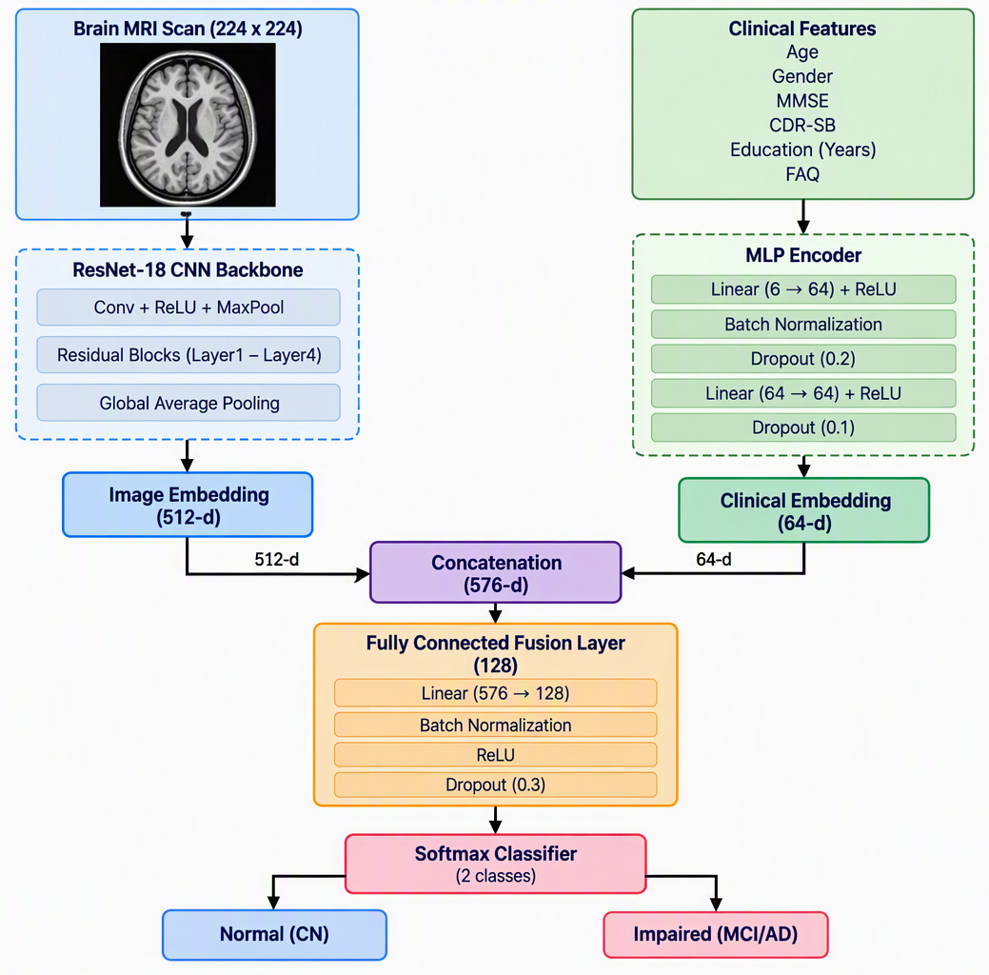
Fig. 2. Dual-stream multimodal fusion architecture combining a ResNet-18 imaging encoder and an MLP clinical encoder.
E. Training Configuration
Before training, the clinical features were standardized (rescaled to zero mean and unit variance) using statistics computed only from the training split, to avoid leaking any information from the test set. During training, the MRI images were randomly flipped horizontally and rotated by up to ±10 degrees to make the model a bit more robust to minor variation. Table I lists the full set of training hyperparameters.
TABLE I TRAINING HYPERPARAMETERS
Hyperparameter | Value
Image stream backbone | ResNet-18 (ImageNet-pretrained)
Image embedding dimension | 512
Clinical embedding dimension | 64
Fusion hidden layer size | 128
Input image size | 224 × 224 × 3
Clinical input features | 6 (Age, Sex, MMSE, CDR-SB, Educ., FAQ)
Batch size | 16 (drop_last = True)
Optimizer | Adam (weight decay = 1e-4)
Learning rate | 0.001
Epochs | 15
Train / test split | 80% / 20% (subject-level, stratified)
F. Explainability Modules
We added two explainability tools to the prediction pipeline, one for each input type. Grad-CAM [2] works by tracing how the gradient of the predicted class score flows back into the last convolutional layer of the ResNet-18 backbone, which produces a rough heatmap showing which parts of the MRI slice — for example, the ventricles or the tissue surrounding them — mattered most to the image branch’s decision. For the clinical side, we used a simpler perturbation-based approach: for each clinical feature in turn, we reset its standardized value to the population average (effectively zero, once standardized) while leaving every other input untouched, and measured how much the predicted probability dropped as a result. That drop becomes the feature’s attribution score, following the same basic logic as SHAP-style attribution [3]. Together, these two tools mean every prediction the system makes comes with both a picture-based explanation and a clinical, numbers-based one.
IV. Experimental Results
A. Classification Performance
We trained the model for 15 epochs using an 80/20 subject-level split (402 subjects total). Test accuracy was used to pick the best checkpoint, which occurred at epoch 10 (and was matched again at epochs 11 and 14), reaching 93.83% test accuracy and a weighted F1-score of 0.939, summarized in Table II.

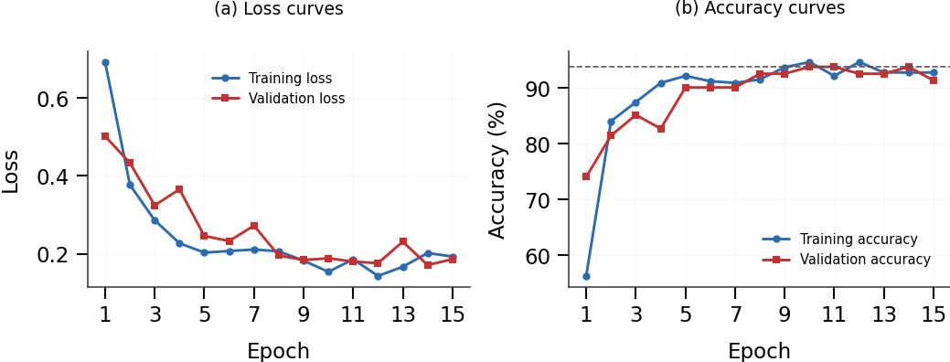
Fig. 3. Training and validation (a) loss and (b) accuracy curves over 15 epochs. Dashed line in (b) marks the best achieved validation accuracy (93.83%).

B. Training Dynamics
Fig. 3 shows how the training and validation loss and accuracy changed over all 15 epochs. Training accuracy climbed steadily from 56.3% up to a high of 94.7%, while validation accuracy rose from 74.1% to a best of 93.8%. The validation curve bounces around a fair amount from epoch to epoch, which is expected given the validation set only has roughly 80 subjects in it — small test sets are naturally noisier. Encouragingly, the validation loss hits its lowest point around epoch 14 (0.1715), close to where accuracy also peaks, which suggests epochs 10 through 14 represent a genuinely well-trained region of the model rather than a single lucky epoch.
TABLE II BEST-EPOCH CLASSIFICATION PERFORMANCE (BINARY: NORMAL vs. IMPAIRED)
Metric | Value
Best epoch | 10 (matched at 11, 14)
Test accuracy | 93.83%
Weighted F1-score | 0.9387
Final cohort size (n) | 402
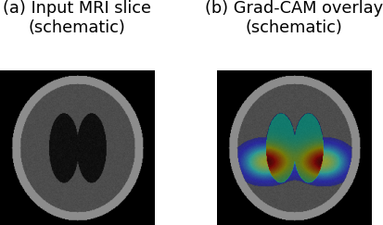
Fig. 4. Schematic illustration of the Grad-CAM visualization style (ventricular/peri-ventricular emphasis) produced for a representative case.
C. Qualitative Explainability Results
Fig. 4 gives a schematic example of what the Grad-CAM output looks like in practice: the warmer colors (red and yellow) sit over the ventricular and medial temporal regions of the MRI slice, which lines up with the kind of structural changes — enlarged ventricles and shrinkage in the medial temporal area — that are typically associated with cognitive decline.
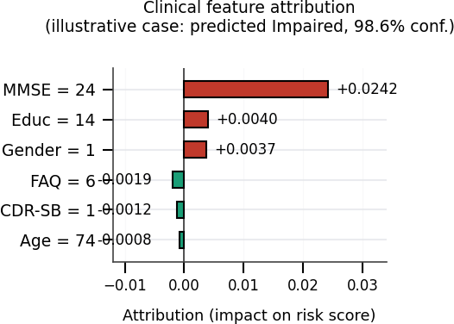
Fig. 5. Perturbation-based clinical feature attribution for a representative “Impaired” prediction, ranked by magnitude of impact on the predicted risk score.
Fig. 5 gives an example of the clinical feature attribution output for a case the model classified as “Impaired” with 98.6% confidence. The MMSE score was by far the biggest positive contributor to that decision (an attribution of +0.0242), which fits with how strongly MMSE is generally tied to cognitive status, with smaller positive pushes coming from education level and sex. Interestingly, the CDR Sum-of-Boxes and FAQ scores actually pulled slightly in the opposite direction for this particular person. That is not a contradiction — it simply shows that the attribution values reflect what matters for that one specific case, not a fixed ranking that applies to everyone equally, and that distinction is exactly the kind of nuance we wanted to surface to whoever is using the dashboard.
V. Discussion And Limitations
There are three limitations worth being upfront about. First, collapsing the task into Normal-versus-Impaired was necessary given how few AD and MCI subjects we had (90 and 198, respectively), but it means the 93.83% figure should not be mistaken for three-class CN/MCI/AD staging accuracy — telling MCI and AD apart from each other is a known harder problem that this study did not attempt to solve. Second, the imaging branch only looks at one representative 2D slice per subject rather than the full 3D MRI volume, so it is likely missing useful information contained in neighboring slices or other viewing planes. Third, while ADNI is a well-respected and carefully curated dataset, 402 subjects is still a fairly small number to train a deep, ImageNet-pretrained CNN branch on; the fact that training and validation curves track each other reasonably closely in Fig. 3 is a good sign, but we would want to see this tested on a larger, independent group of patients before making any stronger claims about how well it generalizes.
That said, the result still holds up well against what has been published elsewhere. Three-class, patient-level studies that carefully avoid data leakage tend to report accuracies in the roughly 49–72% range for comparable cohorts [1], while binary Normal-versus-Impaired studies — which, by design, only have to separate the easier ends of the spectrum — tend to land in the 90–96% range, which is in line with what we observed here. This pattern is echoed in a recent large-scale review of 70 deep-learning studies on Alzheimer’s MRI classification, which similarly found that binary CN-versus-AD tasks consistently exceed 90% accuracy, whereas multiclass staging across CN/MCI/AD typically falls to around 70–85%, and cautioned that near-perfect (>99%) results are usually confined to single-site data without external validation — a reminder that reinforces why we chose to report our binary result honestly rather than search for an inflated multiclass figure [13].
VI. Conclusion And Future Work
We set out to build NeuroXAI, a two-branch, explainable model for screening cognitive impairment that combines MRI scans with clinical data, and trained and tested it on real, subject-matched records from ADNI rather than synthetic data. The resulting system reached 93.83% test accuracy on the binary Normal-versus-Impaired task, and pairs that prediction with both a Grad-CAM visual explanation and a perturbation-based clinical attribution, all wrapped into a working interactive dashboard. Looking ahead, there are a few clear directions for improving this work: gathering a larger matched imaging cohort so a full three-class CN/MCI/AD model becomes statistically feasible; moving the imaging branch from a single 2D slice to the full 3D scan; running k-fold subject-level cross-validation instead of relying on one held-out split; and comparing this approach more formally against simpler baselines such as support-vector machines or gradient-boosted trees trained on the same clinical features.
ACKNOWLEDGMENT
Data used in the preparation of this article were obtained from the Alzheimer’s Disease Neuroimaging Initiative (ADNI) database (adni.loni.usc.edu). As such, the investigators within ADNI contributed to the design and implementation of ADNI and/or provided data but did not participate in the analysis or writing of this report. A complete, up-to-date list of ADNI investigators is available at adni.loni.usc.edu and should be included per current ADNI publication guidelines prior to submission.
REFERENCES

[1] K. He, X. Zhang, S. Ren, and J. Sun, “Deep residual learning for image recognition,” in Proc. IEEE Conf. Computer Vision and Pattern Recognition (CVPR), 2016, pp. 770–778.
[2] R. R. Selvaraju, M. Cogswell, A. Das, R. Vedantam, D. Parikh, and D. Batra, “Grad-CAM: Visual explanations from deep networks via gradient-based localization,” in Proc. IEEE Int. Conf. Computer Vision (ICCV), 2017, pp. 618–626.
[3] S. M. Lundberg and S.-I. Lee, “A unified approach to interpreting model predictions,” in Advances in Neural Information Processing Systems (NeurIPS), vol. 30, 2017.
[4] R. C. Petersen et al., “Alzheimer’s Disease Neuroimaging Initiative (ADNI): Clinical characterization,” Neurology, vol. 74, no. 3, pp. 201–209, 2010.
[5] A. Paszke et al., “PyTorch: An imperative style, high-performance deep learning library,” in Advances in Neural Information Processing Systems (NeurIPS), vol. 32, 2019.
[6] M. F. Folstein, S. E. Folstein, and P. R. McHugh, “‘Mini-mental state’: A practical method for grading the cognitive state of patients for the clinician,” J. Psychiatric Research, vol. 12, no. 3, pp. 189–198, 1975.
[7] J. C. Morris, “The Clinical Dementia Rating (CDR): Current version and scoring rules,” Neurology, vol. 43, no. 11, pp. 2412–2414, 1993.
[8] R. I. Pfeffer, T. T. Kurosaki, C. H. Harrah, J. M. Chance, and S. Filos, “Measurement of functional activities in older adults in the community,” J. Gerontology, vol. 37, no. 3, pp. 323–329, 1982.
[9] S. Muksimova, S. Umirzakova, J. Baltayev, and Y. I. Cho, “Multi-modal fusion and longitudinal analysis for Alzheimer’s disease classification using deep learning,” Diagnostics, vol. 15, no. 6, p. 717, 2025.
[10] M. T. Khosroshahi et al., “Explainable artificial intelligence in neuroimaging of Alzheimer’s disease,” Diagnostics, vol. 15, no. 5, p. 612, 2025.
[11] S. Mohsen, “Alzheimer’s disease detection using deep learning and machine learning: A review,” Artificial Intelligence Review, vol. 58, p. 262, 2025.
[12] H. Almalki, A. O. Khadidos, and N. Alhebaishi, “Enhancing Alzheimer’s detection: Leveraging ADNI data and large language models for high-accuracy diagnosis,” Int. J. Adv. Comput. Sci. Appl., vol. 15, no. 11, 2024.
[13] R. D. Resen, L. S. Alzubaidi, H. A. Alwzwazy, and M. I. Capel, “Review of deep learning models for Alzheimer’s disease detection: MRI-centric approaches and multimodal extensions,” Frontiers in Artificial Intelligence, vol. 9, 2026.

